**Final Lab Worksheet**

**Name:** Sachin Atwal **UID:** 20BCS5169

**Class:** 704-B **Subject:** Computer Networks Lab

**Aim:**

Create network to implement TCP/IP protocol

**Objective:**

Understand how to assign IP address to computer.

**Requirements:**

Cisco packet tracer, Java

**STEPS FOR EXPERIMENT:**

Step 1: Create a system using routers, switches and different end devices.

Step 2: Connect all the end- devices with switch.

Step 3: Connect router with each other.

Step 4: Assign IPs to all devices.

Step 5: Drop Packet and start simulation.

**Connections:**

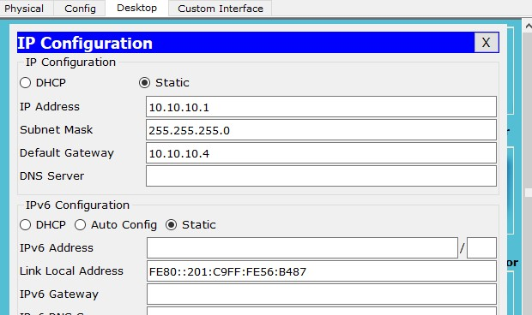

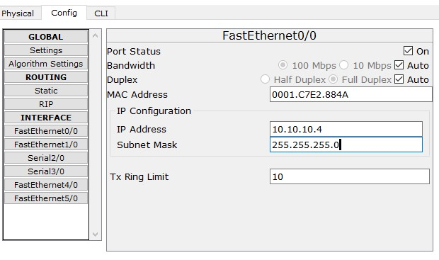

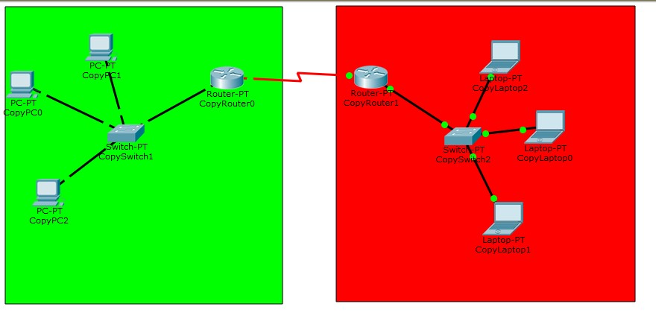

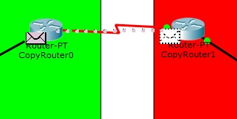

**RESULT:**

